Meta Title:
Shop Certified Pre-Owned Rolex Watches for Sale
Meta Description:
Grab your favorite Pre owned Rolex watch at an unbeatable price from Swiss Ice Co. Browse our collection and find your ideal fit Rolex watch.
Watches Rolex | https://swissiceco.com/collections/watches-rolex | Pre owned rolex watches  rolex watches  Rolex watches for sale  rolex watch  rolex watch men  rolex watch women  Ladies Rolex watches  rolex watches for men  mens rolex watch  cheapest rolex watch  lowest rolex watch

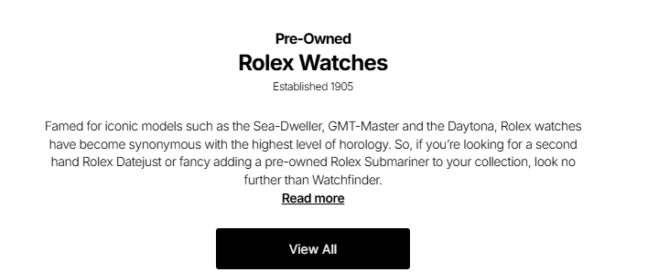

Pre Owned Rolex Watches
Widely known for famous models such as the Sea-Dweller, GMT-Master and the Daytona, Rolex wristwatches represent the highest level of horology in the field of watchmaking. So if you are interested in purchasing pre owned Rolex watches or want to expand your collection by adding a second-hand Rolex Submariner watch, Swiss Ice Co is your one-stop solution.

Shop Now

Find Your Perfect Wrist Companion at Affordable Rates:

Are you searching for unique pre-owned Rolex watches for sale that will last a lifetime? Swiss Ice Co gives you easy access to all these fantastic pre-owned Rolex watches. All of our timepieces are thoroughly checked and refurbished by highly skilled and qualified master watchmakers. Moreover, they also ensure these timepieces are fully functional at optimum levels. Find the Rolex of your wish at an extremely low price now!

Rolex for Eternity:

Since 1905, Rolex has been a premium brand devoted to producing extraordinary wristwatches. A Rolex watch continues Swiss watchmaking excellence and mastery, along with strict adherence to quality, reliability, and sophistication. Swiss Ice Co knows the importance of a Rolex watch, and we offer a fine collection of carefully tested Rolex watches for men and women to our valued customers.

Explore Our Collection of Elegantly Designed Rolex Models:

Our extensive assortment of pre-owned ladies' Rolex watches and man Rolex Watches comprises a remarkably wide choice of different sizes and types. Take a look at some of the famous used Rolex watch models that we have stored for you:

Datejust 41mm:
If you do not want a compact timepiece, you will like the Datejust 41mm. This model of Rolex watch is available in different dial colors as well as comprises the finest Oyster bracelet, which ensures flawless durability.

Datejust II:
Another beauty from the house of Rolex is the Datejust II. While having a case diameter of 41mm and improved dialing, it’s a great divergence for anyone who is searching for a classic look with a modern twist.

Daytona:
If you are a racing enthusiast, the Daytona will surely be an ideal watch for you to own. This watch looks like any other stylish watch with its three-sub-dial layout, tachymeter bezel, and a chronograph function.

Milgauss:
The Milgauss is one of the best pieces of Rolex that was created to satisfy the needs of people who expect quality. Likely the most popular style, this watch has an anti-magnetic case making it excellent for performance.

Oyster Perpetual:
Another model that can be considered as timeless, the Oyster Perpetual is unpretentious and elegant. Available in numerous dials, here is a timeless model that caters for those who have a special affection for minimalism.

Oyster Perpetual 39:
The case size of this model is 39mm, making it an ideal, slim model for those who do not want to wear bulky watches. This watch comes in many dial options, from simple black to extraordinary sunburst colorful ones.

Oysterdate:
The design of this timepiece design makes this model a vintage kind that Rolex ever produce. With a two-tone dial and the Oyster bracelet, the Oysterdate represents the traditional and an excellent example of watchmaking art.

Oysterquartz Datejust:
The Oysterquartz Datejust is considered today’s option for the fashion-oriented client. Featuring a modern look and Quartz movement, it will be suitable for those individuals who want an accurate and stylish watch.

Witness Low Prices and High-Quality Like Never Before:

Swiss Ice Co has been selling Rolex’s pre-owned watches with a mission to provide our clients cheapest Rolex watches in the best quality. Our offered collection of the lowest Rolex watch prices starts from $2,399.95 only.Here at our store, you can undoubtedly purchase a Rolex watch that is to your liking and within your means. All our watches are examined and maintained prior to being placed on sale, so you are provided with a fully functional women's and men's Rolex watch.

Why Choose Swiss Ice Co?

If you are searching for a Rolex watch for men or a Rolex watch for women then Swiss Ice Co is your one stop solution. Here you will find not only the most popular wristwatches but also the quality, style, and reliability of the wristwatches. Our expert watchmakers have years of experience in the collection of men's and ladies Rolex watches therefore all the watches that you will find here are in good condition.

Greater flexibility in payment and shipping options is provided to make our customers’ buying process as pleasant as possible. Our customer relations department is 24/7, ready to answer any queries or give advice you might need to decide which Rolex watch to buy.

Grab Your Timeless Classic Pre-owned Rolex Watch Today:

Do not let this chance slip away for you to own a beautiful pre-owned Rolex watch from Swiss Ice Co. We have the best pricing, as well as offering the highest quality watches and have some of the best customer care you will ever come across. Check out our range of second-hand Rolex watches available at our stores in San Francisco and Los Angeles.

